BIRLA INSTITUTE OF TECHNOLOGY AND SCIENCE, PILANI
BIO F215, BIOPHYSICS

SECOND SEMESTER 2016 – 2017
MID-SEMESTER EXAM (CLOSED BOOK)
Full marks: 50 DATE: 08.03.17 DURATION: 90 Mins.
- Answer to the point
- Irrelevant and verbose answer may attract penalty
- Steps in each calculation carry marks

1. a) Explain the following fact with proper diagram (whenever necessary) [3X2=6]
i) Ramachandran map of allowed region of amino acid is constructed on the basis of di-peptide. However, it is used to evaluate protein conformation.
ii) In nature, α-helix more abundant than 3₁₀-helix and π-helix.
iii) In many enzymes His residue are located at the active site of enzyme.
b) Mutations are the result of changes in the amino acid sequence of proteins, and may thus affect the secondary or tertiary structure of the protein, altering its ability to function. Some mutations are more damaging than others. Based on your knowledge of the amino acid properties and their potential contribution to secondary and tertiary structure, can you explain the following observations?
If one replaces Pro, Gly by another amino acid, this often has radical effects on protein structure. Leu, Ile or Met can be interchanged with little effect, and Lys and Arg are often interchangeable. Sometimes Asp and Glu can be switched without effect, but sometimes not. [6]
c) The following sequence of amino acids found in α-helix. How will the distribution of polar and non polar amino acids appear on the surface of the helix? Can you see are any other potentially favorable side chain interactions arising from the three-dimensional arrangement? If same motif from other protein interact with each other what would be the interacting residues?
Leu₁-Pro-Glu-Met-Phe₅-Thr-Lys-Leu-Gln-His₁₀-Ala-Leu-Arg₁₃ [5]
d) The pK₁ and pK₂ values for valine are 2.32 and 9.62. In the dipeptide Val-Val, these values are 3.09 and 8.25 while the tripeptide Val-Val-Val has values of 3.28 and 7.95. Explain the trends for the values of pK₁ and pK₂ in each peptide. [3]

2. a) Calculate the degree of deprotonation of the sidechain of cysteine at neutral pH , given that the side chain –SH group has a pKa of 8.20. At what pH condition (acidic/basic/neutral) di-sulphide bond formation would be preferred and why? [3]
b) i) Proteins in cells contain mostly “L” amino acids. However, certain bacterial cell contains “D” amino acids in their proteins. What could be possible reasons? ii) What structural change you expect when a D-amino acid instead of L-amino acid is introduced in turn region? [2+2]
c) Draw a possible Ramachandran plot of following protein structure (PDB id:2BRD). [3]
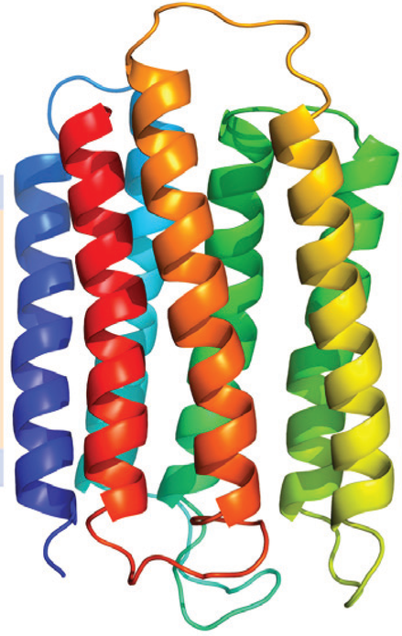

3. a) Consider a relaxed, closed-circular DNA plasmid that has 1000 base pairs with writhe = 0. An intercalator is added, such that there is one intercalator per 100 base pairs. The effect of the intercalator is to cause the twist between the base pairs that flank it to be reduced to zero. Will the resulting intercalator-bound DNA be positively or negatively supercoiled? [Show your calculation] [3]
b) Mention the reasons for following observation about DNA helix. (i) Zig-Zac backbone
(ii) Right handed helix (iii) ~3.4 nm pitch (iv) Unequal Grooves. [4]
c) What are the reasons for sugar puckering in DNA? Draw C1’exo (Twist) sugar pucker. Which type of DNA helix could adopt this sugar pucker? Justify. [1+2+2]
d) What would be most probable structure of DNA in gas phase? Justify your answer. [3]
e) G-G base pairing in genome is not very rare. Among different possible hydrogen bonding schemes Hoogsteen G-G bonding is prevalent. Draw Hoogsteen H-bonding scheme. [2]

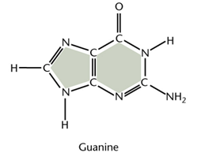

f) What structural changes will move a “B-DNA” to “A-DNA”? [3]

---------------------------------------------------------------------------------------------------------------------

